ASSIGNMENT 2.1

HALL NO:2303A51426
BATCH:28

Task 1: Statistical Summary for Survey Data
Task
Generate a Python function that takes a list of numerical survey responses and calculates the mean, minimum, and maximum values.
Prompt (Used in Google Gemini – Colab)
"Generate a Python function that accepts a list of numbers and returns the mean, minimum, and maximum values. Also show an example execution."
Code:
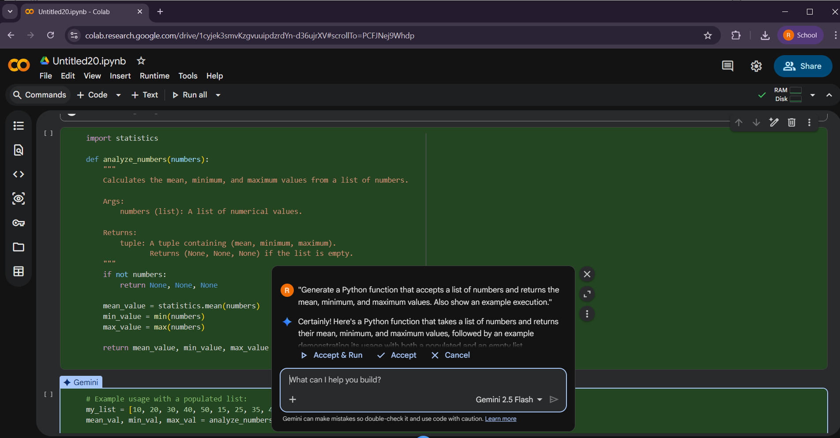
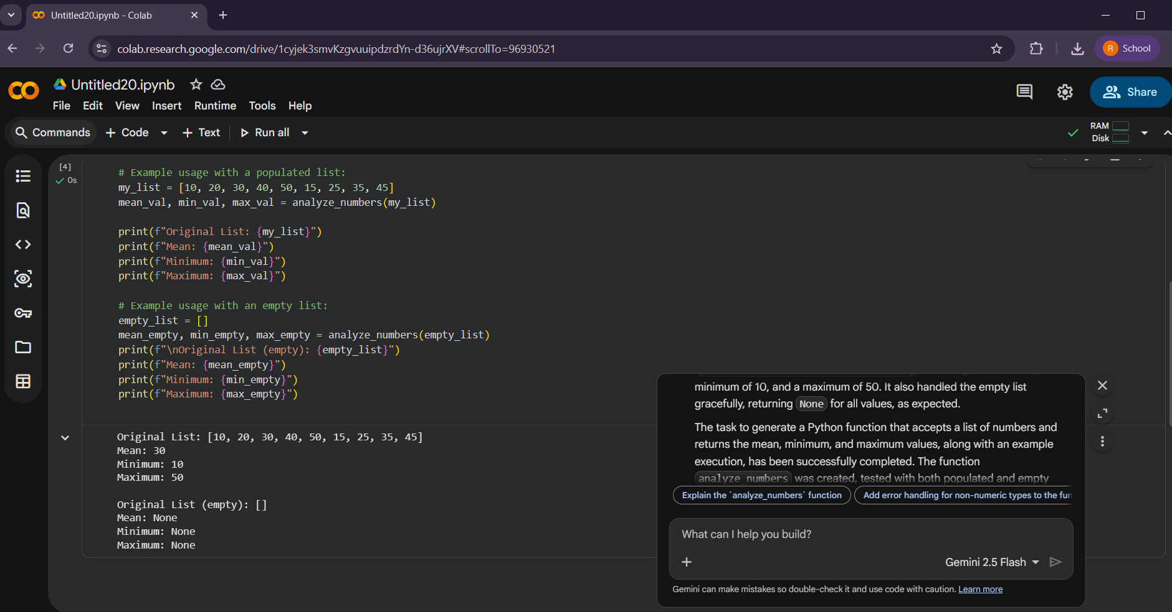
Output:
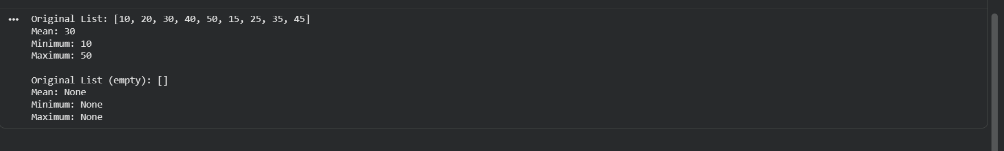
Justification
This function efficiently computes statistical measures using Python built-in functions. It improves readability, reduces code length, and ensures accurate results, making it suitable for real-world survey data analysis

Task 2: Armstrong Number – AI Comparison
Task:
Generate an Armstrong number checker using Google Gemini and GitHub Copilot, and compare their outputs and clarity.
Prompt (Gemini):
"Write a Python program to check whether a given number is an Armstrong number."
Prompt (GitHub Copilot)
"Create a Python function that validates whether a number is an Armstrong number with clear logic and comments."
Code (Gemini Output):
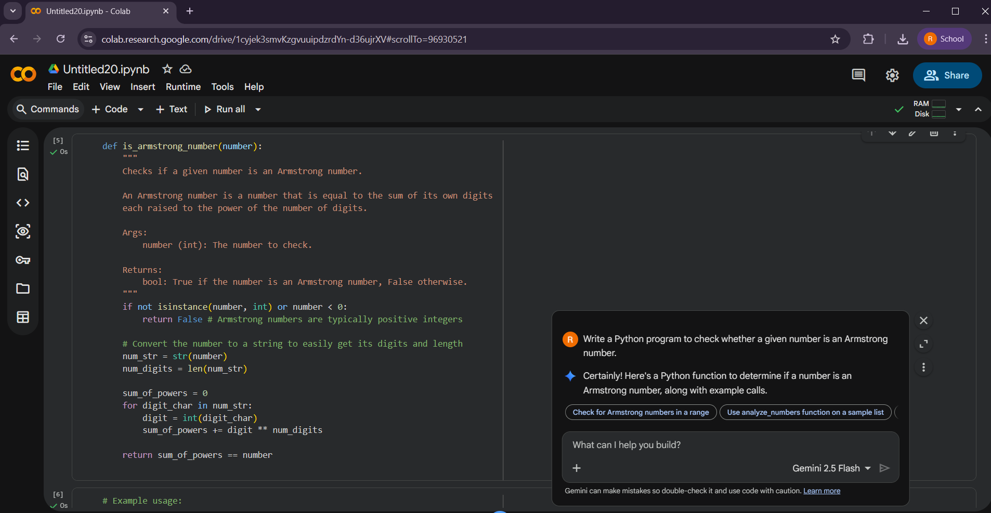
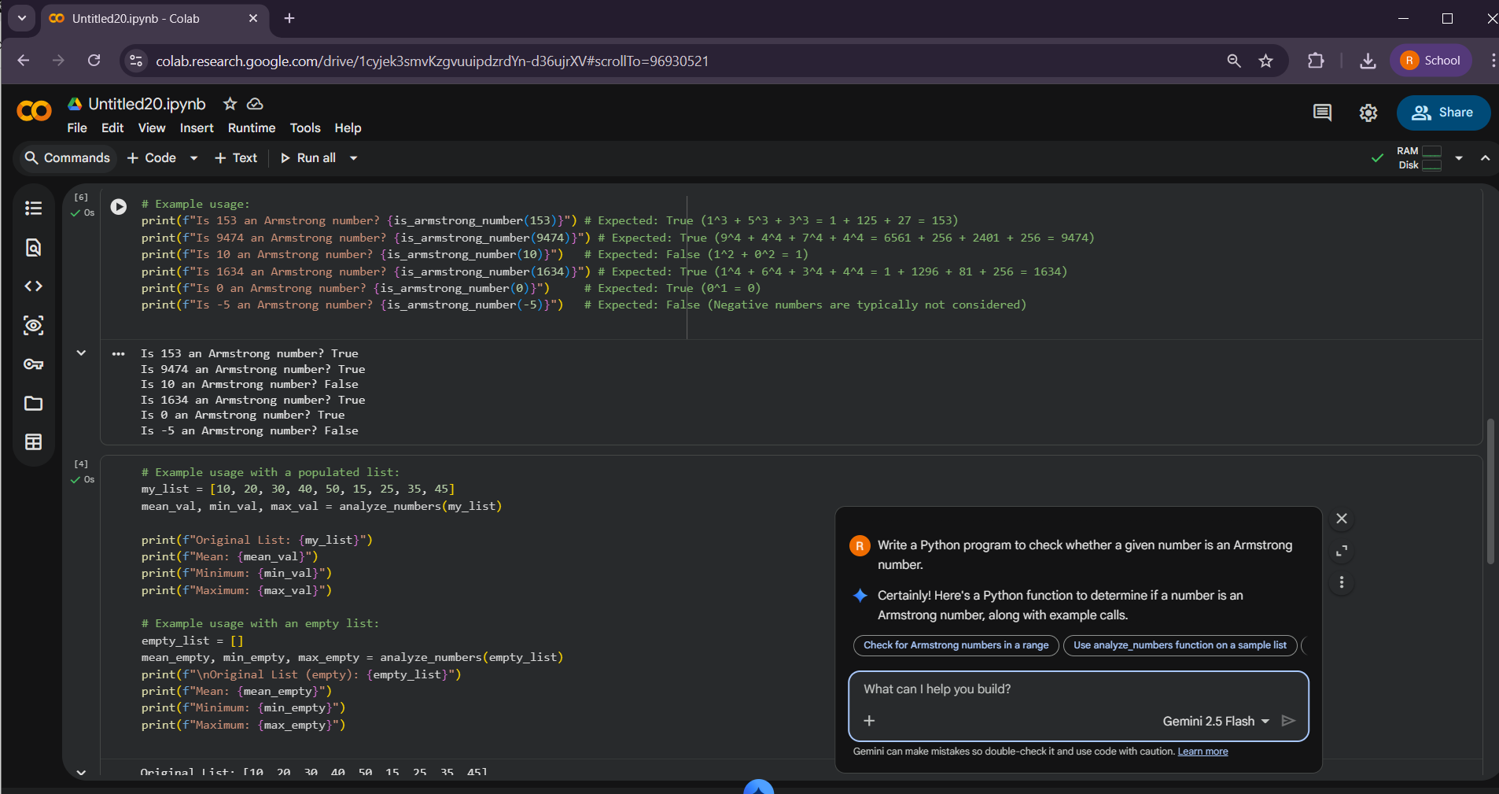
Output:
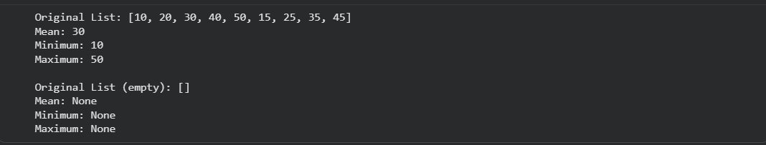
Code (Copilot Output):
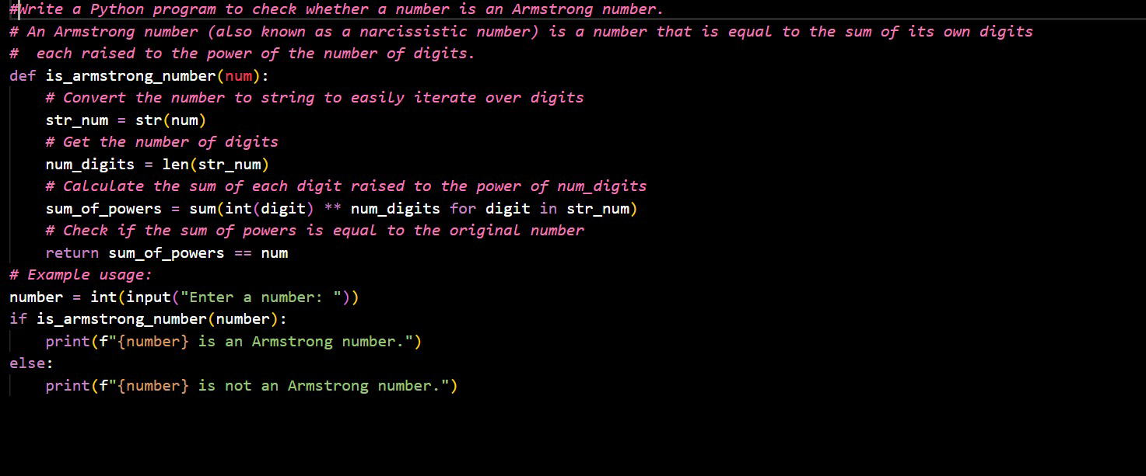
Output:
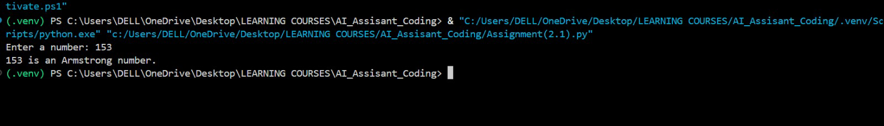
Feature | Gemini (Google Colab) | Copilot (VS Code)
Code clarity | High – code is structured with clear flow and validation | Medium – logic is correct but less structured
Use of functions | Yes – uses a well-defined function with validation | Yes – uses a function but with minimal safeguards
Readability | Good – descriptive variable names and spacing | Good – concise but slightly compact
Comments | More – includes detailed docstring and inline comments | Less – basic comments only
Logic approach | Direct – step-by-step logic easy to follow | Optimized – uses concise expressions (generator)
Error handling | Present – checks input type and negative values | Not present – assumes valid input
Suitability for learning | High – beginner-friendly and explanatory | Medium – better for experienced users
Justification: (Comparison between Gemini AI and GitHub Copilot)

Task 3: Leap Year Validation Using Cursor AI
Task
Generate two versions of a Python program to check leap years using different prompts in Cursor AI.
Prompt 1
"Write a simple Python program to check whether a year is a leap year."
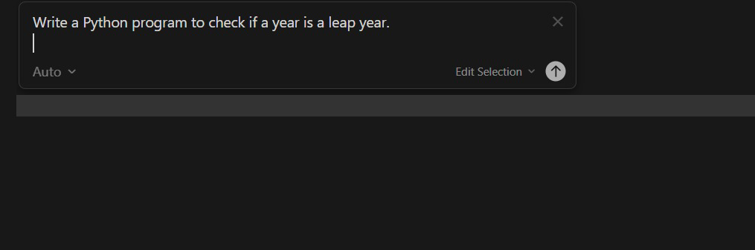
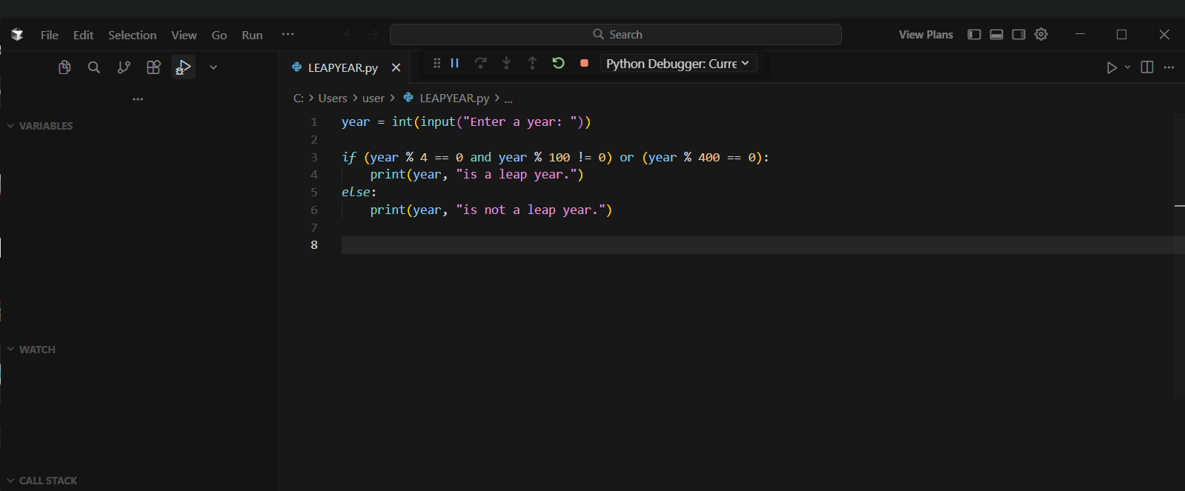
Output:
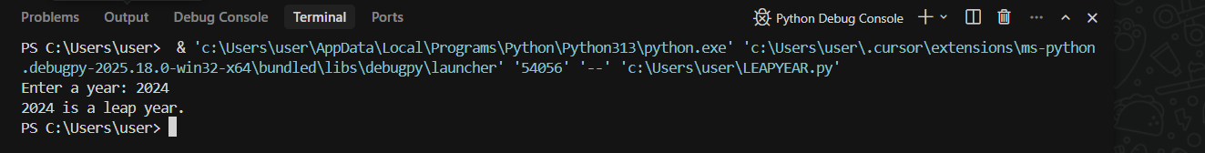
Prompt2:
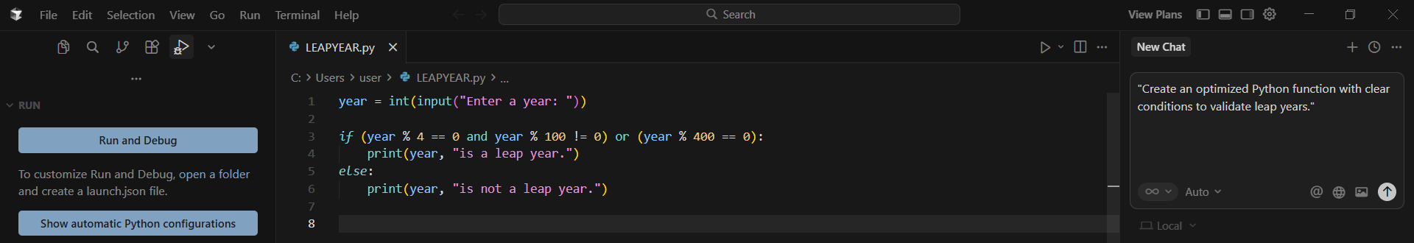
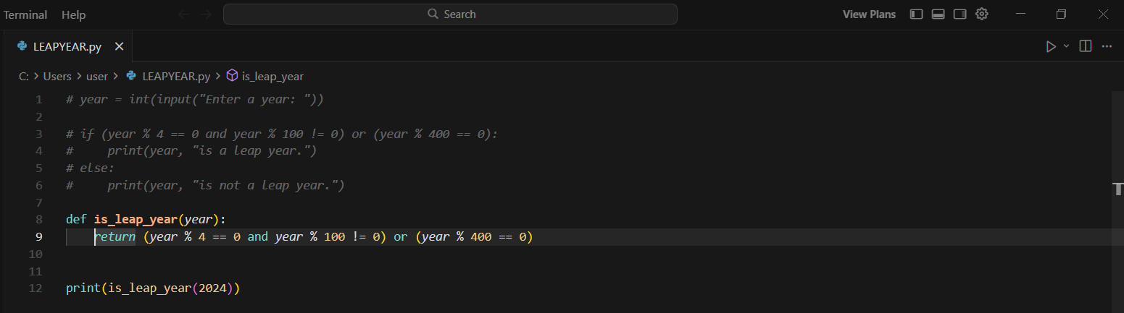
Output:

Justification:
The second version is more modular and reusable. Cursor AI adapts code quality based on prompt specificity, highlighting the importance of precise instructions.

Task 4: Student Logic + AI Refactoring (Odd/Even Sum)
Task
Write a Python program to calculate the sum of odd and even numbers in a tuple, then refactor it using AI.
Original Code (Student Logic)
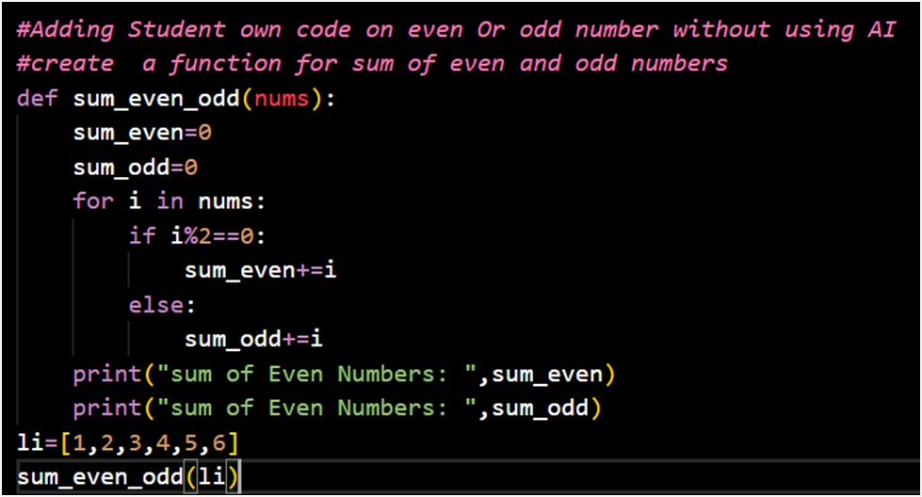
Output:
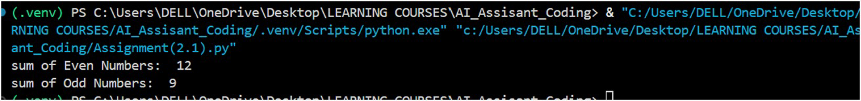

Refactored Code (AI Assisted)
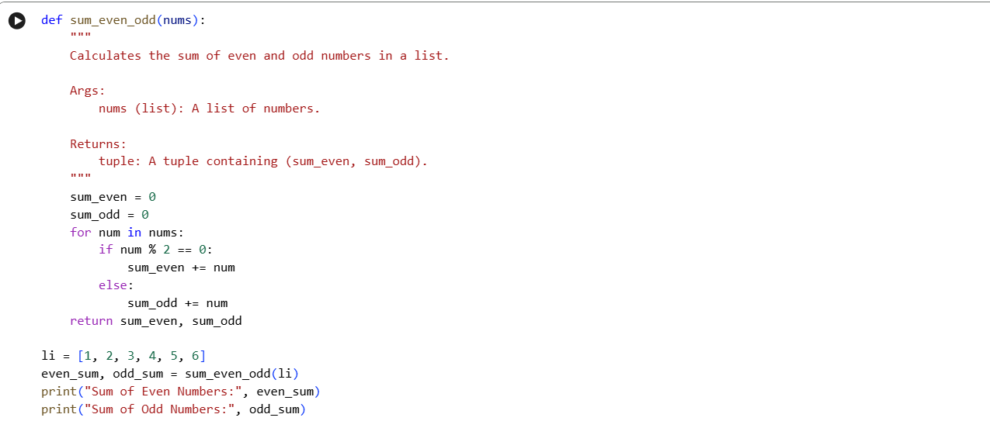

Output:
Justification:
1.Both programs correctly separate even and odd numbers using the modulus (% 2) condition.
2.The first code is student-written and directly prints results, making it easy to understand for beginners.
3.The second code improves structure by using a docstring and returning values instead of printing inside the function.
4. Returning values in the optimized code increases reusability and makes it suitable for larger programs.
5.Overall, the first code is good for learning basic logic, while the second code follows better programming practices.

